Module 10 : Calculations in Tableau

1. Numeric Calculation: What is the profit ratio of $22,000 bin of Sales?

Output:

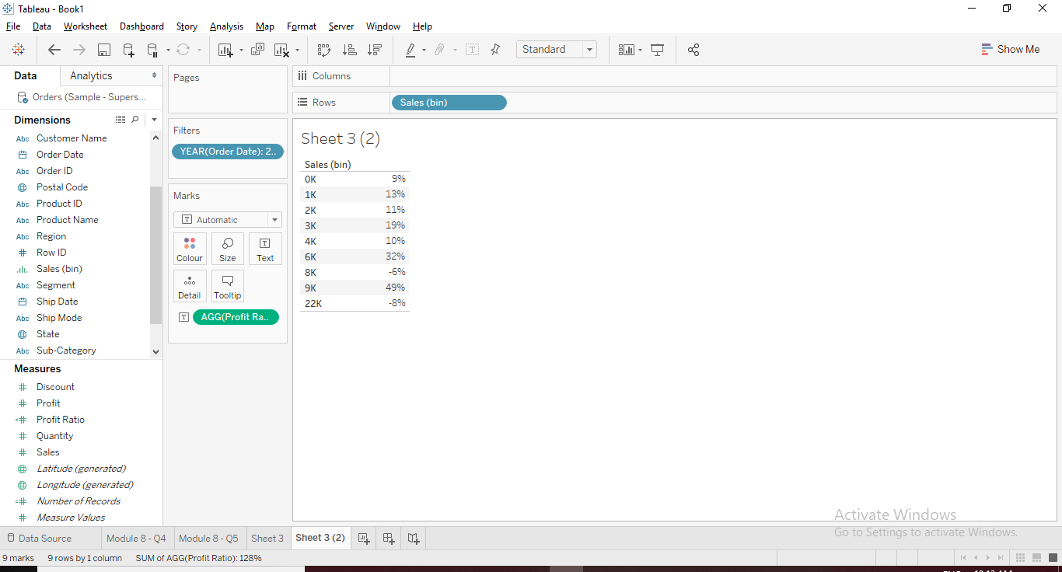

1. String Calculation: The “Names.xlsx” input data source provided contains the names of a few customers, however, the names are not in proper case. Using string calculations bring all the names to “Proper Case”.

Input Data:

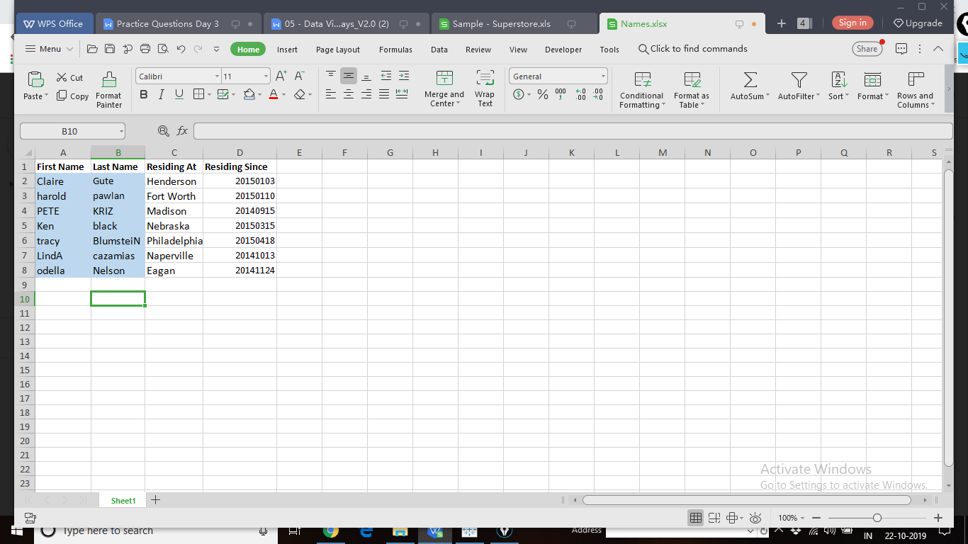

Output:

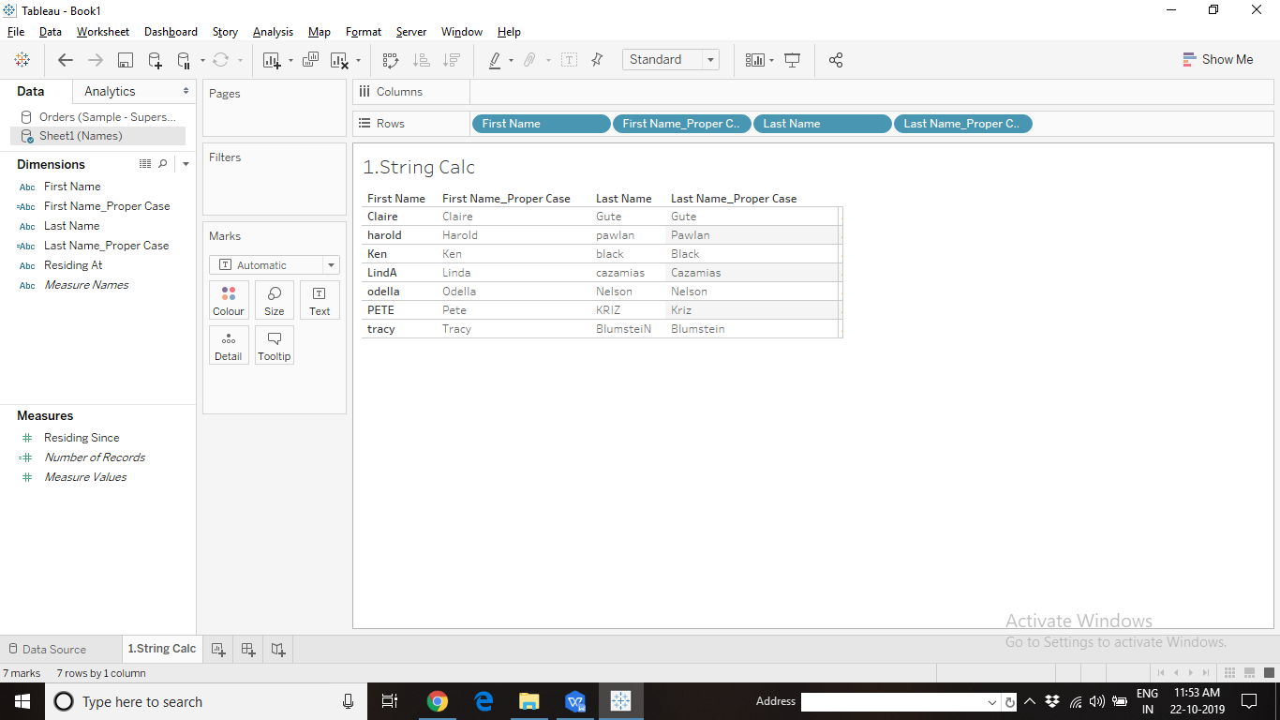

1. Date Calculation: In the Names.xlsx data source, the “Residing Since” column contains the date since the customer has been residing in the given city. However, Tableau could not interpret the Date field properly. It is being treated as a “Numeric” field as shown in the picture below. Convert “Residing Since” into a Date field.

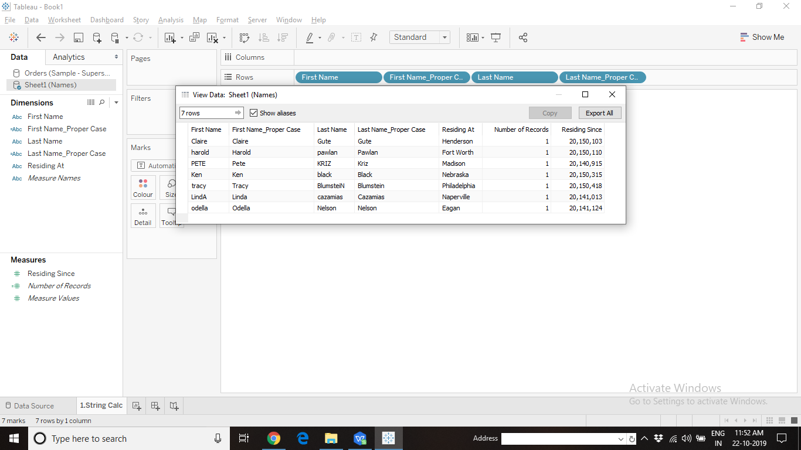

Output:

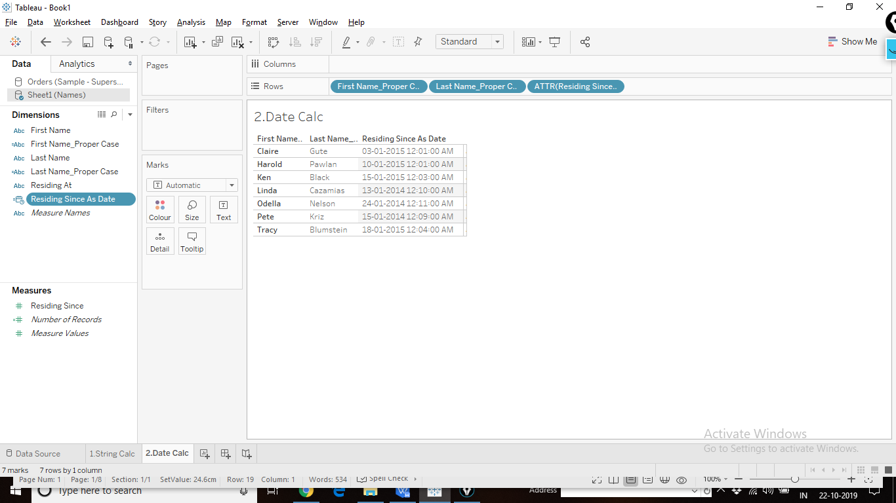

1. Date Calculation: The Shipping Manager of Superstore needs a report of the “Average number of days” taken to ship an order placed, for different states by different ship modes.

Output:

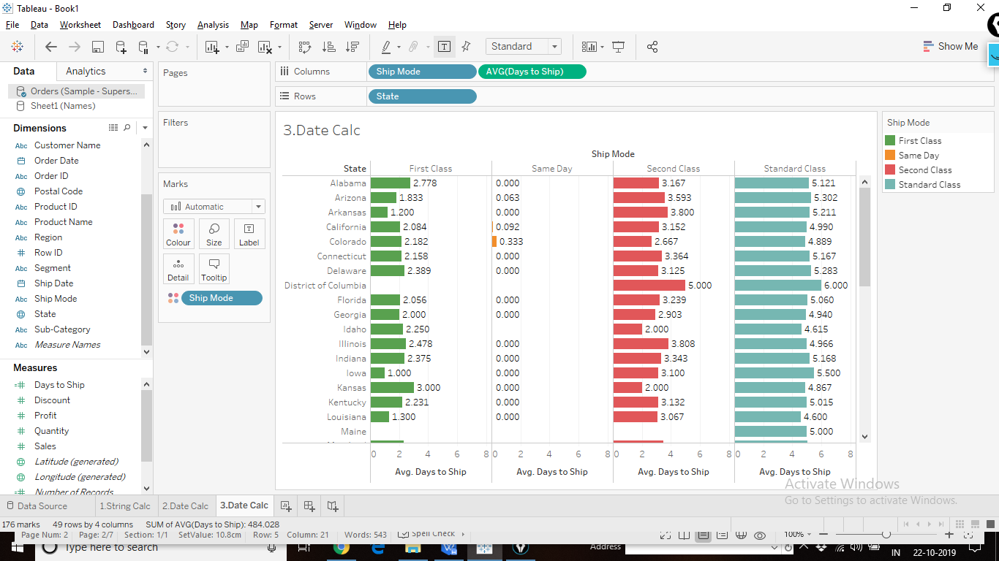

1. Logic Calculation (CASE-WHEN-THEN-END): The “Products.xls” data source contains the product id’s of different products sold by superstore and their Sales information. The customers are not able to identify the type of the product due to the codes used. Create a report with the list of product id’s and mention the full form of the codes used.

Codes are as follows

AP - Appliances

AR - Art

BI - Binders

EN - Envelopes

PA - Paper

ST - Storage

Output:

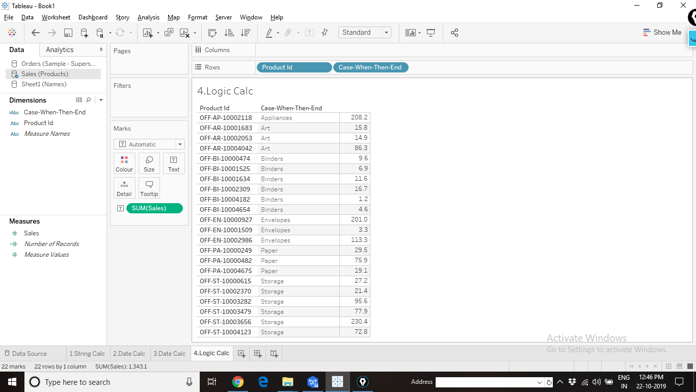

1. Quick Table Calculations: Create a view to display the Sales, Running Sum of Sales and Moving Average of Sales of Superstore (use 45 days before and 45 days after including the current day as the interval for moving average) for different categories.

Output:

